Project Report

College Admission Management System

Submitted by:

Coding Cush

ACKNOWLEDGEMENT

We are pleased to acknowledge your prof. name for their invaluable guidance during the course of this project work. As our project COLLEGE ADMISSION MANAGEMENT SYSTEM which envelops the automation of all work. We have tried our level best to make our project as simple possible.

We would also like to give special thanks to all the talented personalities of our institute who had given us a moral support completing our visual basic project.

CONTENTS

- Introduction
- Problem specification
- Background and related work
- Goals
- Hardware Requirements
- Proposed System
- Overview
- Flow chart / ER Diagram
- Database and MySQL Tables
- Output screen
- System Testing
- Design and implementation constraints
- Supplementary requirements
- Other nonfunctional requirement
- Conclusion
- Reference

INTRODUCTION

Today all the work at the time of admission of the students is done manually by ink and paper, which is very slow and consuming much efforts and time. In the modern world of technology, computer are affecting our lives in more ways than we probably are aware of COMPUTERIZED MANAGEMENT maintaining information of an educational institute, colleges, other the list is endless. The main principle behind the need of college admission system is easy supervision of institutes. It can handle the details of students such as personal details or addmission details. This Student Database has been designed taking into account the practical needs to manage a Students data. Moreover, it provides security at product level as well as user level. Its design concentrates on 2 types of users:

- Admin

- Students

PROBLEM SPECIFICATION

Student admissions are a vital part of any College’s running because students are what keep a College alive. The student admission is one of the most important activities within a College as one cannot survive without students. A poor admissions system can mean fewer students being admitted into a College because of mistakes or an overly slow response time. The process begins with a potential student completing an application form through the Universities and Colleges Admissions Service, the first step for students is to apply directly to the College through a custom online form. The next step is for the Admissions service center has to review the application and ensure that all of the required information has been provided. The application in its entirety is then forwarded, complete with a recommendation, to the respective department’s Admissions Tutor, who has the final say as to whether each potential student is Accepted or rejected. Before making a decision, the Admissions Tutor reviews the application and the additional documentation, comparing the academic credentials to a list of College rankings and previous, similar applications.

BACKGROUND AND RELATED WORK

The main aim of our project is to develop the application which will be useful in college admission system. As this college admission system project includes the admission process of student, starting from when the student takes admission in college in first year till that submission of examination form from the college. The requirement of the student is to:

- User can register himself.
- After registration user can login into system and apply for admission.

- After successful submission of admission form application will pop up in admin panel for review .

- If application is selected user can upload their documents.

- User can update their profile details

- Change his / her own password.

- Admin login should be present who can read as well as view any uploads.

- Admin can select and reject any application.

The student details in separate records are tedious task. Referring to all these records and updating is needed. Since the number of students are growing and management has to handle records of all of the students, it is facing the little bit problems in Maintaining the records of students.

GOALS

The main goal of the system is to automate the process carried out in the organization with improved performance and realize the vision of paperless admission. Some of the goals of the system are listed below:

- Manage large number of student details.

- Manage all details of student who registered for the course and send appropriate details about the course to the students account.

- Create student accounts and maintain the data’s effectively.

- View all the details of the students.

- Create the statistical reports.

- Reduce the work load in interview the students for selection and Counseling should be very effective rather than direct methods.

HARDWARE REQUIRMENT

CPU | : | Intel i3 Processor
RAM | : | 1 GB
HDD | : | 1 TB
MOITOR | : | V.G.A, LCD, LED

Keyboard, Mouse, Printer.

PROPOSED SYSTEM

- It is automated computerized web based software system.

• It uses technologies like PHP,HTML, MYSQL.

- It is easy to operate.

- Attractive User Interface.

OVERVIEW

- Overall Description will describe major components of the system, interconnection and external interfaces.

- Specific Requirements will describe the functions of actors, their role in the system and constraints.

Overall Description:

The rest of this document will give further details on the overall product description, including the hardware, software, and communications interfaces, product functions, user characteristics, and any assumptions that will be made.

Specific Requirements:

The college will also include the specific requirements needed. These will include the functions, performance, design, and software attributes. This document is organized in a logical manner and is easy to follow. Readers should refer to the table of contents, appendices, or index if looking for something in specific. Otherwise, reading this document from start to finish will start with a vague description and get more specific and detailed as changing sections and reading further.

FLOW CHART

User flow chart

CAMS

User Signup

After Signup
Login

Apply for admission
Submit

Admin Flow Chart

CAMS

Login

View All User Info
And
View the admission Application

Admission application Selected Rejected

Signup
Use Case flow Diagram (User)

Login

User Dashboard

Apply for Admission Application

User
Selected Application
Upload Docs
Change Password
Update Profile
Use Case flow Diagram (admin)

Login

Admin Dashboard

View user details /
View Application

Select / Reject
Admission Applications

Search Application by
Name / Email / Contact number

Admin
Create and Manage
Categories
Publish and Manage public notice
Update Profile
Change Password
ER Diagram

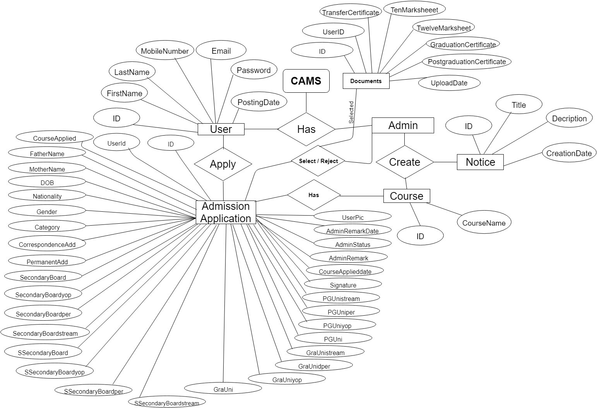

Database and MySQL Tables

MYSQL- MySQL ("My S-Q-L", officially, but also called "My Sequel") is (as of July 2013) the world's second most widely used open-source relational database management system (RDBMS). It is named after co-founder Michael Widenius daughter, My. The SQL phrase stands for Structured Query Language. The MySQL development project has made its source code available under the terms of the GNU General Public License, as well as under a variety of proprietary agreements. MySQL was owned and sponsored by a single for-profit firm, the Swedish company MySQL AB, now owned by Oracle Corporation .MySQL is a popular choice of database for use in web applications, and is a central component of the widely used LAMP open source web application software stack (and other 'AMP' stacks). LAMP is an acronym for "Linux, Apache, MySQL, Perl/PHP/Python." Free-software-open source projects that require a full-featured database management system often use MySQL. For commercial use, several paid editions are available, and offer additional functionality. Applications which use MySQL databases Library Management System include: TYPO3, MODx, Joomla, WordPress, phpBB, MyBB, Drupal and other software. MySQL is also used in many high-profile, large-scale websites, including Wikipedia, Google (though not for searches), Facebook, Twitter, Flickr, and YouTube.

Database tables

In this project various tables used for maintain the information.

tbladmin

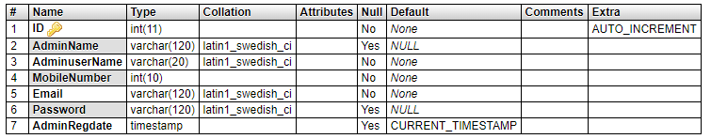

tbluser
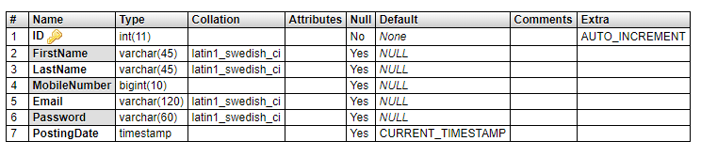

tblcourse

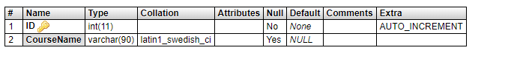

tbladmapplications
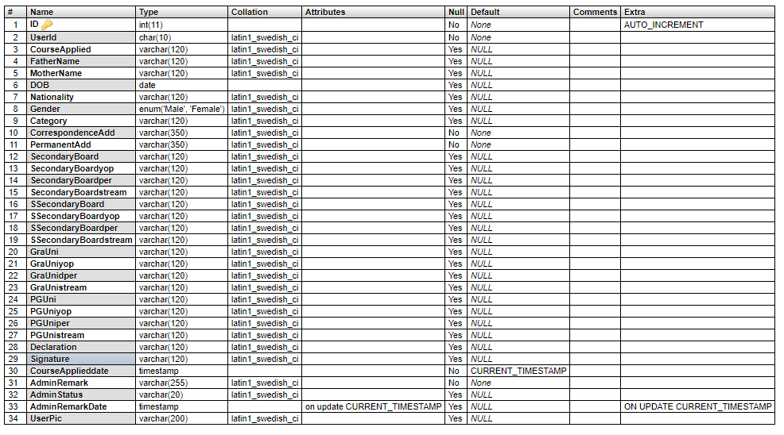

tbldocument

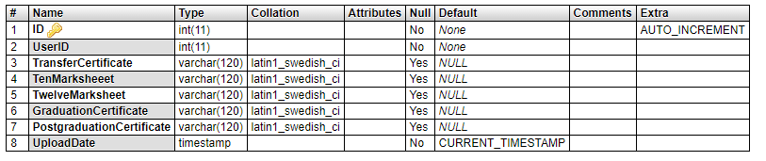

tblnotice
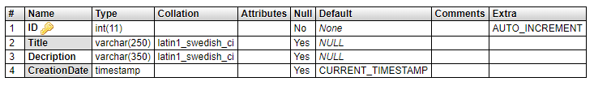

Database Tables Relation

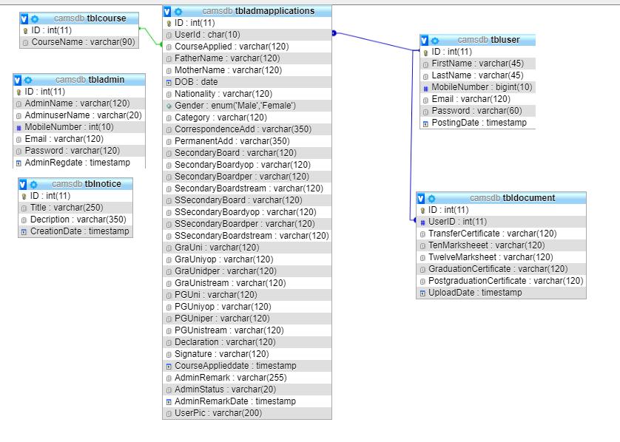

Output SCREENS
User Signup (signup.php)
Code of the signup.php page
- <?php
- session_start();
- error_reporting(0);
- include('includes/dbconnection.php');
- if(isset($_POST['submit']))
- {
- $fname=$_POST['firstname'];
- $lname=$_POST['lastname'];
- $contno=$_POST['contactno'];
- $email=$_POST['email'];
- $password=md5($_POST['password']);
- $ret=mysqli_query($con, "select Email from tbluser where Email='$email' || MobileNumber='$contno'");
- $result=mysqli_fetch_array($ret);
- if($result>0){
- $msg="This email or Contact Number already associated with another account";
- }
- else{
- $query=mysqli_query($con, "insert into tbluser(FirstName, LastName,MobileNumber, Email, Password) value('$fname', '$lname','$contno', '$email', '$password' )");
- if ($query) {
- $msg="You have successfully registered";
- }
- else
- {
- $msg="Something Went Wrong. Please try again";
- }
- }
- }
- ?>
- <!DOCTYPE html>
- <html class="loading" lang="en" data-textdirection="ltr">
- <head>
- <title>College Addmission Management System
- </title>
- <link href="https://fonts.googleapis.com/css?family=Open+Sans:300,300i,400,400i,600,600i,700,700i|Quicksand:300,400,500,700"
- rel="stylesheet">
- <link href="https://maxcdn.icons8.com/fonts/line-awesome/1.1/css/line-awesome.min.css"
- rel="stylesheet">
- <!-- BEGIN VENDOR CSS-->
- <link rel="stylesheet" type="text/css" href="app-assets/css/vendors.css">
- <link rel="stylesheet" type="text/css" href="app-assets/vendors/css/forms/icheck/icheck.css">
- <link rel="stylesheet" type="text/css" href="app-assets/vendors/css/forms/icheck/custom.css">
- <!-- END VENDOR CSS-->
- <!-- BEGIN MODERN CSS-->
- <link rel="stylesheet" type="text/css" href="app-assets/css/app.css">
- <!-- END MODERN CSS-->
- <!-- BEGIN Page Level CSS-->
- <link rel="stylesheet" type="text/css" href="app-assets/css/core/menu/menu-types/vertical-menu.css">
- <link rel="stylesheet" type="text/css" href="app-assets/css/core/colors/palette-gradient.css">
- <link rel="stylesheet" type="text/css" href="app-assets/css/pages/login-register.css">
- <!-- END Page Level CSS-->
- <!-- BEGIN Custom CSS-->
- <link rel="stylesheet" type="text/css" href="assets/css/style.css">
- <!-- END Custom CSS-->
- <script type="text/javascript">
- function checkpass()
- {
- if(document.signup.password.value!=document.signup.repeatpassword.value)
- {
- alert('Password and Repeat Password field does not match');
- document.signup.repeatpassword.focus();
- return false;
- }
- return true;
- }
- </script>
- </head>
- <body class="vertical-layout vertical-menu 1-column bg-cyan bg-lighten-2 menu-expanded fixed-navbar"
- data-open="click" data-menu="vertical-menu" data-col="1-column">
- <!-- fixed-top-->
- <nav class="header-navbar navbar-expand-md navbar navbar-with-menu navbar-without-dd-arrow fixed-top navbar-dark navbar-shadow">
- <div class="navbar-wrapper">
- <div class="navbar-header">
- <ul class="nav navbar-nav flex-row">
- <li class="nav-item mobile-menu d-md-none mr-auto"><a class="nav-link nav-menu-main menu-toggle hidden-xs" href="#"><i class="ft-menu font-large-1"></i></a></li>
- <li class="nav-item">
- <a class="navbar-brand" href="../index.php">
- <h3 class="brand-text">College Admission Management System | User Signup</h3>
- </a>
- </li>
- <li class="nav-item d-md-none">
- <a class="nav-link open-navbar-container" data-toggle="collapse" data-target="#navbar-mobile"><i class="la la-ellipsis-v"></i></a>
- </li>
- </ul>
- </div>
- <div class="navbar-container">
- <div class="collapse navbar-collapse justify-content-end" id="navbar-mobile">
- <ul class="nav navbar-nav">
- <li class="nav-item"><a class="nav-link mr-2 nav-link-label" href="../index.php"><i class="ficon ft-arrow-left"></i></a></li>

- </ul>
- </div>
- </div>
- </div>
- </nav> <div class="app-content content">
- <div class="content-wrapper">
- <div class="content-header row">
- </div>
- <div class="content-body">
- <section class="flexbox-container">
- <div class="col-12 d-flex align-items-center justify-content-center">
- <div class="col-md-4 col-10 box-shadow-2 p-0">
- <div class="card border-grey border-lighten-3 m-0">
- <div class="card-header border-0 pb-0">
- <div class="card-title text-center">
- <h4 style="font-weight: bold"> CAMS User Signup</h4>
- </div>
- <h6 class="card-subtitle line-on-side text-muted text-center font-small-3 pt-2">
- <span>Please Sign Up</span>
- </h6>
- </div>
- <div class="card-content">
- <div class="card-body">
- <p style="font-size:16px; color:red" align="center"> <?php if($msg){
- echo $msg;
- } ?> </p>
- <form method="post" name="signup" onSubmit="return checkpass();">

- <div class="row">
- <div class="col-12 col-sm-6 col-md-6">
- <fieldset class="form-group position-relative has-icon-left">
- <input type="text" name="firstname" id="firstname" required="true" class="form-control input-lg"
- placeholder="First Name" tabindex="1">
- <div class="form-control-position">
- <i class="ft-user"></i>
- </div>
- </fieldset>
- </div>
- <div class="col-12 col-sm-6 col-md-6">
- <fieldset class="form-group position-relative has-icon-left">
- <input type="text" name="lastname" id="lastname" required="true" class="form-control input-lg"
- placeholder="Last Name" tabindex="2">
- <div class="form-control-position">
- <i class="ft-user"></i>
- </div>
- </fieldset>
- </div>
- </div>
- <fieldset class="form-group position-relative has-icon-left">
- <input type="text" name="contactno" id="contactno" class="form-control input-lg"
- placeholder="Contact Number" required="true" maxlength="10" tabindex="3" required data-validation-required-message="Please enter display name.">
- <div class="form-control-position">
- <i class="ft-user"></i>
- </div>
- <div class="help-block font-small-3"></div>
- </fieldset>
- <fieldset class="form-group position-relative has-icon-left">
- <input type="email" name="email" id="email" class="form-control input-lg" placeholder="Email Address"
- tabindex="4" required="true" required data-validation-required-message="Please enter email address.">
- <div class="form-control-position">
- <i class="ft-mail"></i>
- </div>
- <div class="help-block font-small-3"></div>
- </fieldset>
- <div class="row">
- <div class="col-12 col-sm-6 col-md-6">
- <fieldset class="form-group position-relative has-icon-left">
- <input type="password" name="password" id="password" class="form-control input-lg"
- placeholder="Password" tabindex="5" required>
- <div class="form-control-position">
- <i class="la la-key"></i>
- </div>
- <div class="help-block font-small-3"></div>
- </fieldset>
- </div>
- <div class="col-12 col-sm-6 col-md-6">
- <fieldset class="form-group position-relative has-icon-left">
- <input type="password" name="repeatpassword" id="repeatpassword" class="form-control input-lg"
- placeholder="Repeat Password" tabindex="6" data-validation-matches-match="password" required="true"
- data-validation-matches-message="Password & Confirm Password must be the same.">
- <div class="form-control-position">
- <i class="la la-key"></i>
- </div>
- <div class="help-block font-small-3"></div>
- </fieldset>
- </div>
- </div>
- <div class="row mb-1">
- <div class="col-4 col-sm-3 col-md-3">
- <fieldset>
- <input type="checkbox" id="remember-me" class="chk-remember" checked="true" required="true">
- <label for="remember-me"> I Agree</label>
- </fieldset>
- </div>
- <div class="col-8 col-sm-9 col-md-9">
- <p class="font-small-3">By clicking Register, you agree to the <a href="#" data-toggle="modal"
- data-target="#t_and_c_m">Terms and Conditions</a> set
- out by this site, including our Cookie Use.</p>
- </div>
- </div>
- <div class="row">
- <div class="col-6 col-sm-6 col-md-6">
- <button type="submit" name="submit" class="btn btn-info btn-lg btn-block"><i class="ft-user"></i> Register</button>
- </div>
- <div class="col-6 col-sm-6 col-md-6">
- <a href="login.php" class="btn btn-danger btn-lg btn-block"><i class="ft-unlock"></i> Login</a>
- </div>
- <div class="col-6 col-sm-6 col-md-6">

- </div>
- </div>
- </form>
- </div>
- </div>
- </div>
- </div>
- </div>
- </section>
- </div>
- </div>
- </div>
- <footer class="footer fixed-bottom footer-dark navbar-border navbar-shadow">
- <p class="clearfix blue-grey lighten-2 text-sm-center mb-0 px-2">
- <span class="float-md-left d-block d-md-inline-block">Copyright © 2018 <a class="text-bold-800 grey darken-2" >CAMS </a>, All rights reserved. </span>
- </p>
- </footer>
- <script src="/../app-assets/vendors/js/vendors.min.js" type="text/javascript"></script>
- <script src="app-assets/vendors/js/forms/validation/jqBootstrapValidation.js"
- type="text/javascript"></script>
- <script src="app-assets/vendors/js/forms/icheck/icheck.min.js" type="text/javascript"></script>
- <script src="app-assets/js/core/app-menu.js" type="text/javascript"></script>
- <script src="app-assets/js/core/app.js" type="text/javascript"></script>
- <script src="app-assets/js/scripts/customizer.js" type="text/javascript"></script>
- <script src="app-assets/js/scripts/forms/form-login-register.js" type="text/javascript"></script>
- </body>
- </html>

Output Screen

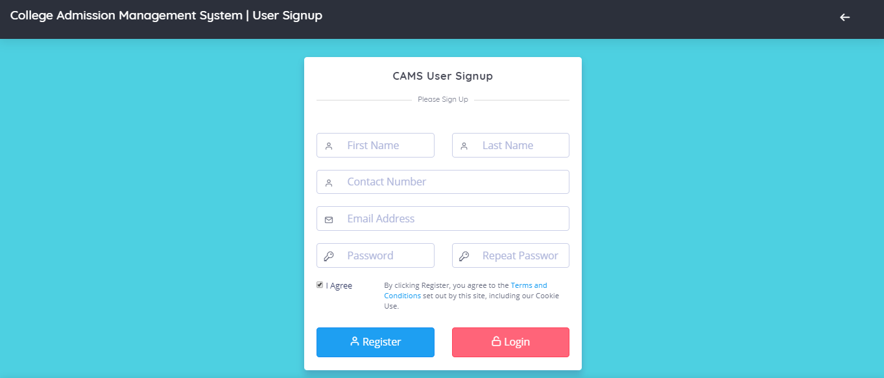

User login (login.php)
Code of the login.php page
- <?php
- session_start();
- error_reporting(0);
- include('includes/dbconnection.php');
- if(isset($_POST['login']))
- {
- $emailcon=$_POST['emailcont'];
- $password=md5($_POST['password']);
- $query=mysqli_query($con,"select ID from tbluser where (Email='$emailcon' || MobileNumber='$emailcon') && Password='$password' ");
- $ret=mysqli_fetch_array($query);
- if($ret>0){
- $_SESSION['uid']=$ret['ID'];
- header('location:dashboard.php');
- }
- else{
- $msg="Invalid Details.";
- }
- }
- ?>
- <!DOCTYPE html>
- <html class="loading" lang="en" data-textdirection="ltr">
- <head>
- <title>User Login
- </title>
- <link href="https://fonts.googleapis.com/css?family=Open+Sans:300,300i,400,400i,600,600i,700,700i|Quicksand:300,400,500,700"
- rel="stylesheet">
- <link href="https://maxcdn.icons8.com/fonts/line-awesome/1.1/css/line-awesome.min.css"
- rel="stylesheet">
- <link rel="stylesheet" type="text/css" href="app-assets/css/vendors.css">
- <link rel="stylesheet" type="text/css" href="app-assets/vendors/css/forms/icheck/icheck.css">
- <link rel="stylesheet" type="text/css" href="app-assets/vendors/css/forms/icheck/custom.css">
- <link rel="stylesheet" type="text/css" href="app-assets/css/app.css">
- <link rel="stylesheet" type="text/css" href="app-assets/css/core/menu/menu-types/vertical-menu.css">
- <link rel="stylesheet" type="text/css" href="app-assets/css/core/colors/palette-gradient.css">
- <link rel="stylesheet" type="text/css" href="app-assets/css/pages/login-register.css">
- <link rel="stylesheet" type="text/css" href="assets/css/style.css">
- </head>
- <body class="vertical-layout vertical-menu 1-column bg-cyan bg-lighten-2 menu-expanded fixed-navbar"
- data-open="click" data-menu="vertical-menu" data-col="1-column">
- <!-- fixed-top-->
- <nav class="header-navbar navbar-expand-md navbar navbar-with-menu navbar-without-dd-arrow fixed-top navbar-dark navbar-shadow">
- <div class="navbar-wrapper">
- <div class="navbar-header">
- <ul class="nav navbar-nav flex-row">
- <li class="nav-item mobile-menu d-md-none mr-auto"><a class="nav-link nav-menu-main menu-toggle hidden-xs" href="#"><i class="ft-menu font-large-1"></i></a></li>
- <li class="nav-item">
- <a class="navbar-brand" href="../index.php">

- <h3 class="brand-text">College Admission Management System | User login</h3>
- </a>
- </li>
- <li class="nav-item d-md-none">
- <a class="nav-link open-navbar-container" data-toggle="collapse" data-target="#navbar-mobile"><i class="la la-ellipsis-v"></i></a>
- </li>
- </ul>
- </div>
- <div class="navbar-container">
- <div class="collapse navbar-collapse justify-content-end" id="navbar-mobile">
- <ul class="nav navbar-nav">
- <li class="nav-item"><a class="nav-link mr-2 nav-link-label" href="../index.php"><i class="ficon ft-arrow-left"></i></a></li>

- </ul>
- </div>
- </div>
- </div>
- </nav>
- <!-- ////////////////////////////////////////////////////////////////////////////-->
- <div class="app-content content">
- <div class="content-wrapper">
- <div class="content-header row">
- </div>
- <div class="content-body">
- <section class="flexbox-container">
- <div class="col-12 d-flex align-items-center justify-content-center">
- <div class="col-md-4 col-10 box-shadow-2 p-0">
- <div class="card border-grey border-lighten-3 m-0">
- <div class="card-header border-0 pb-0">
- <div class="card-title text-center">
- <h4 style="font-weight: bold"> CAMS User Login</h4>
- </div>
- <h6 class="card-subtitle line-on-side text-muted text-center font-small-3 pt-2">
- <span>Login</span>
- </h6>
- </div>
- <div class="card-content">
- <div class="card-body">
- <p style="font-size:16px; color:red" align="center"> <?php if($msg){
- echo $msg;
- } ?> </p>
- <form class="form-horizontal" action="" name="login" method="post">
- <fieldset class="form-group position-relative has-icon-left">
- <input type="text" name="emailcont" id="email" class="form-control input-lg" placeholder="Registered Email or Contact Number"
- required="true" >
- <div class="form-control-position">
- <i class="ft-mail"></i>
- </div>
- <div class="help-block font-small-3"></div>
- </fieldset>
- <fieldset class="form-group position-relative has-icon-left">
- <input type="password" name="password" id="password" class="form-control input-lg"
- placeholder="Password" tabindex="5" required>
- <div class="form-control-position">
- <i class="la la-key"></i>
- </div>
- <div class="help-block font-small-3"></div>
- </fieldset>
- <div class="row">
- <div class="col-6 col-sm-6 col-md-6">
- <button type="submit" name="login" class="btn btn-info btn-lg btn-block"><i class="ft-user"></i> Login</button>
- </div>
- <div class="col-6 col-sm-6 col-md-6">
- <a href="signup.php" class="btn btn-danger btn-lg btn-block" name="login" type="text"><i class="ft-unlock"></i> Register</a>
- </div>
- </div>
- <div class="col-6 col-sm-6 col-md-6">
- <p><a href="forget-password.php">Forgot password?</a></p>
- </div>
- </div>
- </form>
- </div>
- </div>
- </div>
- </div>
- </div>
- </section>
- </div>
- </div>
- </div>
- <footer class="footer fixed-bottom footer-dark navbar-border navbar-shadow">
- <p class="clearfix blue-grey lighten-2 text-sm-center mb-0 px-2">
- <span class="float-md-left d-block d-md-inline-block">Copyright © 2019 <a class="text-bold-800 grey darken-2" >CAMS </a>, All rights reserved. </span>
- </p>
- </footer>
- <script src="/../app-assets/vendors/js/vendors.min.js" type="text/javascript"></script>
- <script src="app-assets/vendors/js/forms/validation/jqBootstrapValidation.js"
- type="text/javascript"></script>
- <script src="app-assets/vendors/js/forms/icheck/icheck.min.js" type="text/javascript"></script>
- <script src="app-assets/js/core/app-menu.js" type="text/javascript"></script>
- <script src="app-assets/js/core/app.js" type="text/javascript"></script>
- <script src="app-assets/js/scripts/customizer.js" type="text/javascript"></script>
- <script src="app-assets/js/scripts/forms/form-login-register.js" type="text/javascript"></script>
- </body>
- </html>
Output Screen



Admission Application Form (addmission-form.php)
Code of the addmission-form.php page

- <?php
- session_start();
- error_reporting(0);
- include('includes/dbconnection.php');
- if (strlen($_SESSION['uid']==0)) {
- header('location:logout.php');
- } else{
- if(isset($_POST['submit']))
- {
- $uid=$_SESSION['uid'];
- $coursename=$_POST['coursename'];
- $fathername=$_POST['fathername'];
- $mothername=$_POST['mothername'];
- $dob=$_POST['dob'];
- $nationality=$_POST['nationality'];
- $gender=$_POST['gender'];
- $category=$_POST['category'];
- $coradd=$_POST['coradd'];
- $peradd=$_POST['peradd'];
- $secboard=$_POST['10thboard'];
- $secyop=$_POST['10thpyear'];
- $secper=$_POST['10thpercentage'];
- $secstream=$_POST['10thstream'];
- $ssecboard=$_POST['12thboard'];
- $ssecyop=$_POST['12thpyear'];
- $ssecper=$_POST['12thpercentage'];
- $ssecstream=$_POST['12thstream'];
- $grauni=$_POST['graduation'];
- $grayop=$_POST['graduationpyeaer'];
- $graper=$_POST['graduationpercentage'];
- $grastream=$_POST['graduationstream'];
- $pguni=$_POST['postgraduation'];
- $pgyop=$_POST['pgpyear'];
- $pgper=$_POST['pgpercentage'];
- $pgstream=$_POST['pgstream'];
- $dec=$_POST['declaration'];
- $sign=$_POST['signature'];
- $upic=$_FILES["userpic"]["name"];

- $extension = substr($upic,strlen($upic)-4,strlen($upic));
- // allowed extensions
- $allowed_extensions = array(".jpg","jpeg",".png",".gif");
- // Validation for allowed extensions .in_array() function searches an array for a specific value.
- if(!in_array($extension,$allowed_extensions))
- {
- echo "<script>alert('Invalid format. Only jpg / jpeg/ png /gif format allowed');</script>";
- }
- else
- {
- // rename user pic
- $userpic=md5($upic).$extension;
- move_uploaded_file($_FILES["userpic"]["tmp_name"],"userimages/".$userpic);
- $query=mysqli_query($con,"insert into tbladmapplications(UserId,CourseApplied,FatherName,MotherName,DOB,Nationality,Gender,Category,CorrespondenceAdd,PermanentAdd,SecondaryBoard,SecondaryBoardyop,SecondaryBoardper,SecondaryBoardstream,SSecondaryBoard,SSecondaryBoardyop,SSecondaryBoardper,SSecondaryBoardstream,GraUni,GraUniyop,GraUnidper,GraUnistream,PGUni,PGUniyop,PGUniper,PGUnistream,Signature,UserPic) value('$uid','$coursename','$fathername','$mothername','$dob','$nationality','$gender','$category','$coradd','$coradd','$secboard','$secyop','$secper','$secstream','$ssecboard','$ssecyop','$ssecper','$ssecstream','$grauni','$grayop','$graper','$grastream','$pguni','$pgyop','$pgper','$pgstream','$sign','$userpic')");
- if ($query) {
- $msg="Data has been added successfully.";
- }
- else
- {
- $msg="Something Went Wrong. Please try again";
- }
- }
- }
- ?>
- <!DOCTYPE html>
- <html class="loading" lang="en" data-textdirection="ltr">
- <head>

- <title>College Addmission Management System</title>
- <link href="https://fonts.googleapis.com/css?family=Open+Sans:300,300i,400,400i,600,600i,700,700i|Quicksand:300,400,500,700"
- rel="stylesheet">
- <link href="https://maxcdn.icons8.com/fonts/line-awesome/1.1/css/line-awesome.min.css"
- rel="stylesheet">
- <link rel="stylesheet" type="text/css" href="app-assets/css/vendors.css">
- <link rel="stylesheet" type="text/css" href="app-assets/css/app.css">
- <link rel="stylesheet" type="text/css" href="app-assets/css/core/menu/menu-types/vertical-menu-modern.css">
- <link rel="stylesheet" type="text/css" href="app-assets/css/core/colors/palette-gradient.css">
- <link rel="stylesheet" type="text/css" href="app-assets/css/plugins/forms/extended/form-extended.css">
- <link rel="stylesheet" type="text/css" href="assets/css/style.css">
- <style>
- .errorWrap {
- padding: 10px;
- margin: 20px 0 0px 0;
- background: #fff;
- border-left: 4px solid #dd3d36;
- -webkit-box-shadow: 0 1px 1px 0 rgba(0,0,0,.1);
- box-shadow: 0 1px 1px 0 rgba(0,0,0,.1);
- }
- .succWrap{
- padding: 10px;
- margin: 0 0 20px 0;
- background: #fff;
- border-left: 4px solid #5cb85c;
- -webkit-box-shadow: 0 1px 1px 0 rgba(0,0,0,.1);
- box-shadow: 0 1px 1px 0 rgba(0,0,0,.1);
- }
- </style>
- </head>
- <body class="vertical-layout vertical-menu-modern 2-columns menu-expanded fixed-navbar"
- data-open="click" data-menu="vertical-menu-modern" data-col="2-columns">
- <?php include('includes/header.php');?>
- <?php include('includes/leftbar.php');?>
- <div class="app-content content">
- <div class="content-wrapper">
- <div class="content-header row">
- <div class="content-header-left col-md-6 col-12 mb-2 breadcrumb-new">
- <h3 class="content-header-title mb-0 d-inline-block">
- View Application
- </h3>
- <div class="row breadcrumbs-top d-inline-block">
- <div class="breadcrumb-wrapper col-12">
- <ol class="breadcrumb">
- <li class="breadcrumb-item"><a href="dashboard.php">Dashboard</a>
- </li>

- </li>
- <li class="breadcrumb-item active">Application
- </li>
- </ol>
- </div>
- </div>
- </div>

- </div>
- <div class="content-body">
- <?php
- $stuid=$_SESSION['uid'];
- $query=mysqli_query($con,"select * from tbladmapplications where UserId=$stuid");
- $rw=mysqli_num_rows($query);
- if($rw>0)
- {
- while($row=mysqli_fetch_array($query)){
- ?>
- <p style="font-size:16px; color:red" align="center">Your Addmission Form already added.</p>
- <table class="table mb-0">
- <tr>
- <th>Course Applied</th>
- <td><?php echo $row['CourseApplied'];?></td>
- </tr>
- <tr>
- <th>Student Pic</th>
- <td><img src="userimages/<?php echo $row['UserPic'];?>" width="200" height="150"></td>
- </tr>
- <tr>
- <th>Father's Name</th>
- <td><?php echo $row['FatherName'];?></td>
- </tr>
- <tr>
- <th>Mother's Name</th>
- <td><?php echo $row['MotherName'];?></td>
- </tr>
- <tr>
- <th>DOB</th>
- <td><?php echo $row['DOB'];?></td>
- </tr>
- <tr>
- <th>Nationality</th>
- <td><?php echo $row['Nationality'];?></td>
- </tr>
- <tr>
- <th>Gender</th>
- <td><?php echo $row['Gender'];?></td>
- </tr>
- <tr>
- <th>Category</th>
- <td><?php echo $row['Category'];?></td>
- </tr>
- <tr>
- <th>Correspondence Address</th>
- <td><?php echo $row['CorrespondenceAdd'];?></td>
- </tr>
- <tr>
- <th>Permanent Address</th>
- <td><?php echo $row['PermanentAdd'];?></td>
- </tr>
- </table>
- <table class="table mb-0">
- <tr>
- <th>#</th>
- <th>Board / University</th>
- <th>Year</th>
- <th>Percentage</th>
- <th>Stream</th>
- </tr>
- <th>10th(Secondary)</th>
- <td><?php echo $row['SecondaryBoard'];?></td>
- <td><?php echo $row['SecondaryBoardyop'];?></td>
- <td><?php echo $row['SecondaryBoardper'];?></td>
- <td><?php echo $row['SecondaryBoardstream'];?></td>
- </tr>
- <tr>
- <th>12th(Senior Secondary)</th>
- <td><?php echo $row['SSecondaryBoard'];?></td>
- <td><?php echo $row['SSecondaryBoardyop'];?></td>
- <td><?php echo $row['SSecondaryBoardper'];?></td>
- <td><?php echo $row['SSecondaryBoardstream'];?></td>
- </tr>
- <tr>
- <th>Graduation</th>
- <td><?php echo $row['GraUni'];?></td>
- <td><?php echo $row['GraUniyop'];?></td>
- <td><?php echo $row['GraUnidper'];?></td>
- <td><?php echo $row['GraUnistream'];?></td>
- </tr>
- <tr>
- <th>Post Graduation/th>
- <td><?php echo $row['PGUni'];?></td>
- <td><?php echo $row['PGUniyop'];?></td>
- <td><?php echo $row['PGUniper'];?></td>
- <td><?php echo $row['PGUnistream'];?></td>
- </tr>
- </table>
- <table class="table mb-0">
- <tr>
- <th>Admin Remark</th>
- <td><?php echo $row['AdminRemark'];?></td>
- </tr>
- <tr>
- <th>Admin Status</th>
- <td><?php
- if($row['AdminStatus']==""){
- echo "admin remark is pending";
- }

- if($row['AdminStatus']=="1"){
- echo "Selected";
- }

- if($row['AdminStatus']=="2"){
- echo "Rejected";
- }
- ?></td>
- </tr>
- <tr>
- <th>Admin Remark Date</th>
- <td><?php echo $row['AdminRemarkDate'];?></td>
- </tr>
- <tr>
- <th colspan="2"><font color="red">Declaration : </font>I hereby state that the facts mentioned above are true to the best of my knowledge and belief.<br />
- (<?php echo $row['Signature'];?>)
- </th>
- </tr>
- </table>
- <?php } } else { ?>
- <form name="submit" method="post" enctype="multipart/form-data">
- <section class="formatter" id="formatter">
- <div class="row">
- <div class="col-12">
- <div class="card">
- <div class="card-header">
- <h4 class="card-title">Addimission Form</h4>

- <div class="heading-elements">
- <ul class="list-inline mb-0">

- <li><a data-action="reload"><i class="ft-rotate-cw"></i></a></li>
- <li><a data-action="expand"><i class="ft-maximize"></i></a></li>

- </ul>
- </div>
- </div>
- <div class="card-content">
- <div class="card-body">
- <?php if($msg){?><div class="succWrap"><strong>SUCCESS</strong>:<?php echo htmlentities($msg); ?> </div><?php }?>

- <div class="row">
- <div class="col-xl-6 col-lg-12">
- <fieldset>
- <h5>Course Applied </h5>
- <div class="form-group">
- <select name='coursename' id="coursename" class="form-control white_bg">
- <option value="">Course Applied</option>
- <?php $query=mysqli_query($con,"select * from tblcourse");
- while($row=mysqli_fetch_array($query))
- {
- ?>
- <option value="<?php echo $row['CourseName'];?>"><?php echo $row['CourseName'];?></option>
- <?php } ?>
- </select>
- </div>
- </fieldset>

- </div>

- <div class="col-xl-6 col-lg-12">
- <fieldset>
- <h5>Student Pic </h5>
- <div class="form-group">
- <input class="form-control white_bg" id="userpic" name="userpic" type="file" required>
- </div>
- </fieldset>
- </div>
- </div>
- <div class="row">
- <div class="col-xl-6 col-lg-12">
- <fieldset>
- <h5>Father's Name </h5>
- <div class="form-group">
- <input class="form-control white_bg" id="fathername" name="fathername" type="text" required>
- </div>
- </fieldset>
- </div>
- <div class="col-xl-6 col-lg-12">
- <fieldset>
- <h5>Mother's Name </h5>
- <div class="form-group">
- <input class="form-control white_bg" id="mothername" name="mothername" type="text" required>
- </div>
- </fieldset>
- </div>
- </div>
- <div class="row">
- <div class="col-xl-4 col-lg-12">
- <fieldset>
- <h5>DOB </h5>
- <div class="form-group">
- <input class="form-control white_bg" id="dob" name="dob" type="text" required>
- </div>
- </fieldset>
- </div>
- <div class="col-xl-4 col-lg-12">
- <fieldset>
- <h5>Nationality </h5>
- <div class="form-group">
- <input class="form-control white_bg" id="nationality" name="nationality" type="text" required>
- </div>
- </fieldset>
- </div>
- <div class="col-xl-4 col-lg-12">
- <fieldset>
- <h5>Gender </h5>
- <div class="form-group">

- <input class="form-control white_bg" id="gender" name="gender" type="text" required>
- </div>
- </fieldset>
- </div>

- </div>
- <div class="row">
- <div class="col-xl-12 col-lg-12">
- <h5>Category :
- <input id="category" name="category" type="radio" value="General" required>General <input id="category" name="category" type="radio" value="OBC" required>OBC <input id="category" name="category" value="SC/ST" type="radio" required>SC/ST <input id="category" name="category" type="radio" value="Other" required>Other </h5>
- </div>
- </div>
- <div class="row" style="margin-top:1%">
- <div class="col-xl-12 col-lg-12">
- <fieldset>
- <h5>Correspondence Address </h5>
- <div class="form-group">
- <input class="form-control white_bg" id="coradd" name="coradd" type="text" required>
- </div>
- </fieldset>
- </div>
- </div>
- <div class="row">
- <div class="col-xl-12 col-lg-12">
- <fieldset>
- <h5>Permanent Address </h5>
- <div class="form-group">
- <input class="form-control white_bg" id="peradd" name="peradd" type="text" required>
- </div>
- </fieldset>
- </div>
- </div>
- <div class="row" style="margin-top: 2%">
- <div class="col-xl-12 col-lg-12"><h4 class="card-title">Education Qualification</h4>
- <hr />
- </div>
- </div>
- <div class="row">
- <div class="col-xl-12 col-lg-12">
- <table class="table mb-0">
- <tr>
- <th>#</th>
- <th>Board / University</th>
- <th>Year</th>
- <th>Percentage</th>
- <th>Stream</th>
- </tr>
- <tr>
- <th>10th(Secondary)</th>
- <td> <input class="form-control white_bg" id="10thboard" name="10thboard" placeholder="Board / University" type="text" required></td>
- <td> <input class="form-control white_bg" id="10thpyeaer" name="10thpyear" placeholder="Year" type="text" required></td>
- <td> <input class="form-control white_bg" id="10thpercentage" name="10thpercentage" placeholder="Percentage" type="text" required></td>
- <td> <input class="form-control white_bg" id="10thstream" name="10thstream" placeholder="Stream" type="text" required></td>
- </tr>
- <tr>
- <th>12th(Senior Secondary)</th>
- <td> <input class="form-control white_bg" id="12thboard" name="12thboard" placeholder="Board / University" type="text" required></td>
- <td> <input class="form-control white_bg" id="12thboard" name="12thpyear" placeholder="Year" type="text" required></td>
- <td> <input class="form-control white_bg" id="12thpercentage" name="12thpercentage" placeholder="Percentage" type="text" required></td>
- <td> <input class="form-control white_bg" id="12thstream" name="12thstream" placeholder="Stream" type="text" required></td>
- </tr>
- <tr>
- <th>Graduation</th>
- <td> <input class="form-control white_bg" id="graduation" name="graduation" placeholder="Board / University" type="text"></td>
- <td> <input class="form-control white_bg" id="graduationpyeaer" name="graduationpyeaer" placeholder="Year" type="text"></td>
- <td> <input class="form-control white_bg" id="graduationpercentage" name="graduationpercentage" placeholder="Percentage" type="text"></td>
- <td> <input class="form-control white_bg" id="graduationstream" name="graduationstream" placeholder="Stream" type="text" ></td>
- </tr>
- <tr>
- <th>Post Graduation</th>
- <td> <input class="form-control white_bg" id="postgraduation" name="postgraduation" placeholder="Board / University" type="text" ></td>
- <td> <input class="form-control white_bg" id="pgpyeaer" name="pgpyear" placeholder="Year" type="text"></td>
- <td> <input class="form-control white_bg" id="pgpercentage" name="pgpercentage" placeholder="Percentage" type="text" ></td>
- <td> <input class="form-control white_bg" id="pgstream" name="pgstream" placeholder="Stream" type="text" ></td>
- </tr>
- </table>
- </div>
- </div>
- </hr>
- <div class="row" style="margin-top: 2%">

- <div class="col-xl-12 col-lg-12"><h4 class="card-title"><b>Declartion</b></h4> <hr />
- </div>
- </div>
- <div class="row">
- <div class="col-xl-12 col-lg-12">
- <h5><b>I hereby state that the facts mentioned above are true to the best of my knowledge and belief.</b></h5>
- </div>
- </div>
- <div class="row">
- <div class="col-xl-4 col-lg-12">
- <fieldset>
- <input class="form-control white_bg" id="signature" name="signature" placeholder="Signature" type="text">
- </fieldset>
- </div>
- </div>
- <div class="row" style="margin-top: 2%">
- <div class="col-xl-6 col-lg-12">
- <button type="submit" name="submit" class="btn btn-info btn-min-width mr-1 mb-1">Submit</button>
- </div>
- </div>
- </div>
- </div>
- </div>
- </div>
- </div>
- </section>
- <?php } ?>
- <!-- Formatter end -->
- </form>
- </div>
- </div>
- </div>
- <?php include('includes/footer.php');?>
- <script src="app-assets/vendors/js/vendors.min.js" type="text/javascript"></script>
- <script src="app-assets/vendors/js/forms/extended/typeahead/typeahead.bundle.min.js"
- type="text/javascript"></script>
- <script src="app-assets/vendors/js/forms/extended/typeahead/bloodhound.min.js"
- type="text/javascript"></script>
- <script src="app-assets/vendors/js/forms/extended/typeahead/handlebars.js"
- type="text/javascript"></script>
- <script src="app-assets/vendors/js/forms/extended/inputmask/jquery.inputmask.bundle.min.js"
- type="text/javascript"></script>
- <script src="app-assets/vendors/js/forms/extended/formatter/formatter.min.js"
- type="text/javascript"></script>
- <script src="../../../app-assets/vendors/js/forms/extended/maxlength/bootstrap-maxlength.js"
- type="text/javascript"></script>
- <script src="app-assets/vendors/js/forms/extended/card/jquery.card.js" type="text/javascript"></script>
- <script src="app-assets/js/core/app-menu.js" type="text/javascript"></script>
- <script src="app-assets/js/core/app.js" type="text/javascript"></script>
- <script src="app-assets/js/scripts/customizer.js" type="text/javascript"></script>
- <script src="app-assets/js/scripts/forms/extended/form-typeahead.js" type="text/javascript"></script>
- <script src="app-assets/js/scripts/forms/extended/form-inputmask.js" type="text/javascript"></script>
- <script src="app-assets/js/scripts/forms/extended/form-formatter.js" type="text/javascript"></script>
- <script src="app-assets/js/scripts/forms/extended/form-maxlength.js" type="text/javascript"></script>
- <script src="app-assets/js/scripts/forms/extended/form-card.js" type="text/javascript"></script>
- </body>
- </html>
- <?php } ?>

Output Screen
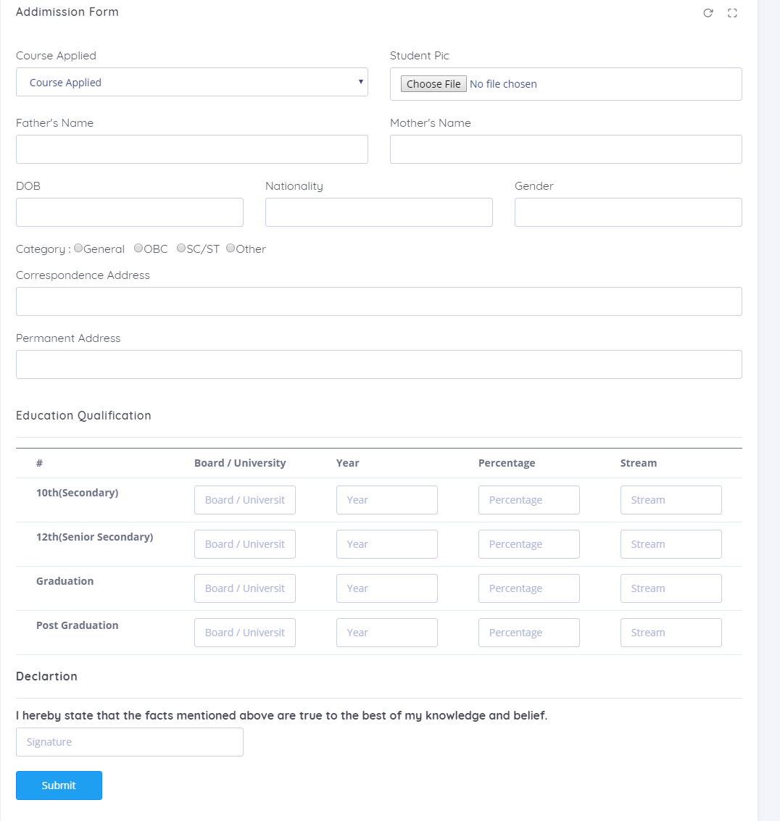

Upload Docs Form (upload-doc.php)
Code of the upload-doc.php page
- <?php
- session_start();
- error_reporting(0);
- include('includes/dbconnection.php');
- if (strlen($_SESSION['uid']==0)) {
- header('location:logout.php');
- } else{

- if(isset($_POST['submit']))
- {
- $uid=$_SESSION['uid'];
- $tc=$_FILES["tcimage"]["name"];
- $tenmarksheet=$_FILES["hscimage"]["name"];
- $twlevemaksheet=$_FILES["sscimage"]["name"];
- $gramarksheet=$_FILES["graimage"]["name"];
- $pgmarksheet=$_FILES["pgraimage"]["name"];

- $extensiontc = substr($tc,strlen($tc)-4,strlen($tc));
- $extensiontm = substr($tenmarksheet,strlen($tenmarksheet)-4,strlen($tenmarksheet));
- $extensiontwm = substr($twlevemaksheet,strlen($twlevemaksheet)-4,strlen($twlevemaksheet));
- $extensiongra = substr($gramarksheet,strlen($gramarksheet)-4,strlen($gramarksheet));
- $extensionpgra = substr($pgmarksheet,strlen($pgmarksheet)-4,strlen($pgmarksheet));
- // allowed extensions
- $allowed_extensions = array(".jpg","jpeg",".png",".gif",".pdf",".PDF");
- // Validation for allowed extensions .in_array() function searches an array for a specific value.
- if(!in_array($extensiontc,$allowed_extensions))
- {
- echo "<script>alert('Invalid format. Only jpg / jpeg/ png /gif/pdf format allowed');</script>";
- }
- elseif(!in_array($extensiontm,$allowed_extensions))
- {
- echo "<script>alert('Invalid format. Only jpg / jpeg/ png /gif/pdf format allowed');</script>";
- }
- elseif(!in_array($extensiontwm,$allowed_extensions))
- {
- echo "<script>alert('Invalid format. Only jpg / jpeg/ png /gif/pdf format allowed');</script>";
- }
- elseif(!in_array($extensiongra,$allowed_extensions))
- {
- echo "<script>alert('Invalid format. Only jpg / jpeg/ png /gif/pdf format allowed');</script>";
- }
- elseif(!in_array($extensionpgra,$allowed_extensions))
- {
- echo "<script>alert('Invalid format. Only jpg / jpeg/ png /gif/pdf format allowed');</script>";
- }

- else
- {
- //rename upload file
- $tc=md5($tc).$extensiontc;
- $tm=md5($tenmarksheet).$extensiontm;
- $twm=md5($twlevemaksheet).$extensiontwm;
- $gra=md5($gramarksheet).$extensiongra;
- $pgra=md5($pgmarksheet).$extensionpgra;
- move_uploaded_file($_FILES["tcimage"]["tmp_name"],"userdocs/".$tc);
- move_uploaded_file($_FILES["hscimage"]["tmp_name"],"userdocs/".$tm);
- move_uploaded_file($_FILES["sscimage"]["tmp_name"],"userdocs/".$twm);
- move_uploaded_file($_FILES["graimage"]["tmp_name"],"userdocs/".$gra);
- move_uploaded_file($_FILES["pgraimage"]["tmp_name"],"userdocs/".$pgra);
- $query=mysqli_query($con,"insert into tbldocument(UserID,TransferCertificate,TenMarksheeet,TwelveMarksheet,GraduationCertificate,PostgraduationCertificate) value('$uid','$tc','$tm','$twm','$gra','$pgra')");
- if ($query) {
- $msg="Data has been uploaded successfully.";
- }
- else
- {
- $msg="Something Went Wrong. Please try again";
- }

- }
- }
- ?>
- <!DOCTYPE html>
- <html class="loading" lang="en" data-textdirection="ltr">
- <head>

- <title>College Addmission Management System</title>
- <link href="https://fonts.googleapis.com/css?family=Open+Sans:300,300i,400,400i,600,600i,700,700i|Quicksand:300,400,500,700"
- rel="stylesheet">
- <link href="https://maxcdn.icons8.com/fonts/line-awesome/1.1/css/line-awesome.min.css"
- rel="stylesheet">
- <link rel="stylesheet" type="text/css" href="app-assets/css/vendors.css">
- <link rel="stylesheet" type="text/css" href="app-assets/css/app.css">
- <link rel="stylesheet" type="text/css" href="app-assets/css/core/menu/menu-types/vertical-menu-modern.css">
- <link rel="stylesheet" type="text/css" href="app-assets/css/core/colors/palette-gradient.css">
- <link rel="stylesheet" type="text/css" href="app-assets/css/plugins/forms/extended/form-extended.css">
- <link rel="stylesheet" type="text/css" href="assets/css/style.css">
- <style>
- .errorWrap {
- padding: 10px;
- margin: 20px 0 0px 0;
- background: #fff;
- border-left: 4px solid #dd3d36;
- -webkit-box-shadow: 0 1px 1px 0 rgba(0,0,0,.1);
- box-shadow: 0 1px 1px 0 rgba(0,0,0,.1);
- }
- .succWrap{
- padding: 10px;
- margin: 0 0 20px 0;
- background: #fff;
- border-left: 4px solid #5cb85c;
- -webkit-box-shadow: 0 1px 1px 0 rgba(0,0,0,.1);
- box-shadow: 0 1px 1px 0 rgba(0,0,0,.1);
- }
- </style>

- </head>
- <body class="vertical-layout vertical-menu-modern 2-columns menu-expanded fixed-navbar"
- data-open="click" data-menu="vertical-menu-modern" data-col="2-columns">
- <?php include('includes/header.php');?>
- <?php include('includes/leftbar.php');?>
- <div class="app-content content">
- <div class="content-wrapper">
- <div class="content-header row">
- <div class="content-header-left col-md-6 col-12 mb-2 breadcrumb-new">
- <h3 class="content-header-title mb-0 d-inline-block">
- Upload Documents
- </h3>
- <div class="row breadcrumbs-top d-inline-block">
- <div class="breadcrumb-wrapper col-12">
- <ol class="breadcrumb">
- <li class="breadcrumb-item"><a href="dashboard.php">Dashboard</a>
- </li>

- </li>
- <li class="breadcrumb-item active">Documents
- </li>

- </ol>
- </div>
- </div>
- </div>

- </div>
- <div class="content-body">
- <!-- Input Mask start -->

- <!-- Formatter start -->
- <?php
- $stuid=$_SESSION['uid'];
- $ret=mysqli_query($con,"select AdminStatus from tbladmapplications join tbluser on tbluser.ID=tbladmapplications.UserID where tbluser.ID='$stuid' ");
- $num=mysqli_fetch_array($ret);
- $adstatus=$num['AdminStatus'];
- if($num>0 && $adstatus=='1' )
- {

- $query=mysqli_query($con,"select * from tbldocument where UserID=$stuid");
- $rw=mysqli_num_rows($query);
- if($rw>0)
- {
- while($row=mysqli_fetch_array($query)){
- ?>
- <p style="font-size:16px; color:red" align="center">Your document is already uploaded.</p>

- <table class="table mb-0">

- <tr>
- <th>Transfer Certificate</th>
- <td><a href="userdocs/<?php echo $row['TransferCertificate'];?>" target="_blank">View File </a></td>
- </tr>
- <tr>
- <th>10th Marksheet</th>
- <td><a href="userdocs/<?php echo $row['TenMarksheeet'];?>" target="_blank">View File </a></td>
- </tr>
- <tr>
- <th>12th Marksheet</th>
- <td><a href="userdocs/<?php echo $row['TwelveMarksheet'];?>" target="_blank">View File </a></td>
- </tr>
- <tr>
- <th>Graduation Certificate</th>
- <td><a href="userdocs/<?php echo $row['GraduationCertificate'];?>" target="_blank">View File </a></td>
- </tr>
- <tr>
- <th>Post Graduation Certificate</th>
- <td><a href="userdocs/<?php echo $row['PostgraduationCertificate'];?>" target="_blank">View File </a></td>
- </tr>

- </table>
- <?php } } else { ?>
- <form name="submit" method="post" enctype="multipart/form-data">
- <section class="formatter" id="formatter">
- <div class="row">
- <div class="col-12">
- <div class="card">
- <div class="card-header">
- <h4 class="card-title">Upload Documents</h4>

- <div class="heading-elements">
- <ul class="list-inline mb-0">

- <li><a data-action="reload"><i class="ft-rotate-cw"></i></a></li>
- <li><a data-action="expand"><i class="ft-maximize"></i></a></li>

- </ul>
- </div>
- </div>
- <div class="card-content">
- <div class="card-body">
- <?php if($msg){?><div class="succWrap"><strong>SUCCESS</strong>:<?php echo htmlentities($msg); ?> </div><?php }?>
- <div class="row">
- <div class="col-xl-6 col-lg-12">
- <fieldset>
- <h5>Transfer Certificate(TC)</h5>
- <div class="form-group">
- <input class="form-control white_bg" id="tcimage" name="tcimage" type="file" required>
- </div>
- </fieldset>

- </div>
- <div class="col-xl-6 col-lg-12">
- <fieldset>
- <h5>10th Marksheet </h5>
- <div class="form-group">
- <input class="form-control white_bg" id="hscimage" name="hscimage" type="file" required>
- </div>
- </fieldset>
- </div>
- </div>
- <div class="row">
- <div class="col-xl-6 col-lg-12">
- <fieldset>
- <h5>12th Mark Sheet </h5>
- <div class="form-group">
- <input class="form-control white_bg" id="sscimage" name="sscimage" type="file" required>
- </div>
- </fieldset>
- </div>
- <div class="col-xl-6 col-lg-12">
- <fieldset>
- <h5>Graduation Certificate(if any) </h5>
- <div class="form-group">
- <input class="form-control white_bg" id="graimage" name="graimage" type="file" required>
- </div>
- </fieldset>
- </div>
- </div>
- <div class="row">
- <div class="col-xl-4 col-lg-12">
- <fieldset>
- <h5>Post Graduation Certificate(if any) </h5>
- <div class="form-group">
- <input class="form-control white_bg" id="pgraimage" name="pgraimage" type="file" required>
- </div>
- </fieldset>
- </div>
- </div>
- <div class="row" style="margin-top: 2%">
- <div class="col-xl-6 col-lg-12">
- <button type="submit" name="submit" class="btn btn-info btn-min-width mr-1 mb-1">Submit</button>
- </div>
- </div>
- </div>
- </div>
- </div>
- </div>
- </div>
- </section>
- <?php } } else if($num>0 && $adstatus==''){ ?>
- <p> Your application is pending with admin </p>
- <?php } else if($num>0 && $adstatus=='2'){ ?>
- <p> Your application has been rejected by admin </p>
- <?php } else{?>
- <p> First fill the application then upload docs. </p>
- <?php } ?>
- <!-- Formatter end -->
- </form>
- </div>
- </div>
- </div>
- <?php include('includes/footer.php');?>
- <script src="app-assets/vendors/js/vendors.min.js" type="text/javascript"></script>
- <script src="app-assets/vendors/js/forms/extended/typeahead/typeahead.bundle.min.js"
- type="text/javascript"></script>
- <script src="app-assets/vendors/js/forms/extended/typeahead/bloodhound.min.js"
- type="text/javascript"></script>
- <script src="app-assets/vendors/js/forms/extended/typeahead/handlebars.js"
- type="text/javascript"></script>
- <script src="app-assets/vendors/js/forms/extended/inputmask/jquery.inputmask.bundle.min.js"
- type="text/javascript"></script>
- <script src="app-assets/vendors/js/forms/extended/formatter/formatter.min.js"
- type="text/javascript"></script>
- <script src="../../../app-assets/vendors/js/forms/extended/maxlength/bootstrap-maxlength.js"
- type="text/javascript"></script>
- <script src="app-assets/vendors/js/forms/extended/card/jquery.card.js" type="text/javascript"></script>
- <script src="app-assets/js/core/app-menu.js" type="text/javascript"></script>
- <script src="app-assets/js/core/app.js" type="text/javascript"></script>
- <script src="app-assets/js/scripts/customizer.js" type="text/javascript"></script>
- <script src="app-assets/js/scripts/forms/extended/form-typeahead.js" type="text/javascript"></script>
- <script src="app-assets/js/scripts/forms/extended/form-inputmask.js" type="text/javascript"></script>
- <script src="app-assets/js/scripts/forms/extended/form-formatter.js" type="text/javascript"></script>
- <script src="app-assets/js/scripts/forms/extended/form-maxlength.js" type="text/javascript"></script>
- <script src="app-assets/js/scripts/forms/extended/form-card.js" type="text/javascript"></script>
- </body>
- </html>
- <?php } ?>

Output Screen

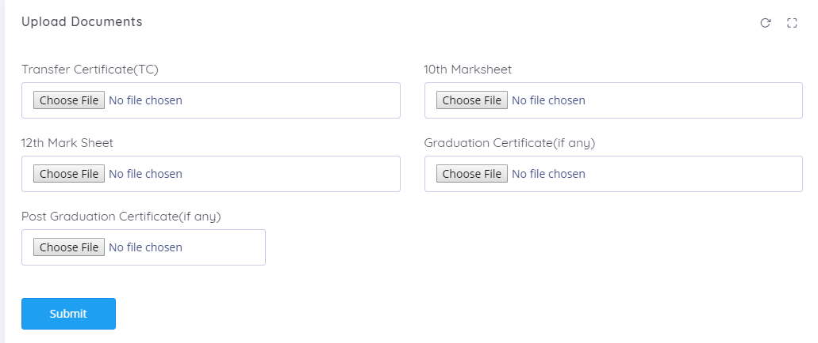

Admin Dashboard (dashboard.php)
Code of the dashboard.php page

- <?php
- session_start();
- error_reporting(0);
- include('includes/dbconnection.php');
- if(strlen($_SESSION['aid'])==0){
- header('location:logout.php');
- } else {
- ?>
- <!DOCTYPE html>
- <html class="loading" lang="en" data-textdirection="ltr">
- <head>
- <title>College Admission Management System | Dashboard</title>
- <link href="https://fonts.googleapis.com/css?family=Open+Sans:300,300i,400,400i,600,600i,700,700i|Quicksand:300,400,500,700"
- rel="stylesheet">
- <link href="https://maxcdn.icons8.com/fonts/line-awesome/1.1/css/line-awesome.min.css"
- rel="stylesheet">
- <link rel="stylesheet" type="text/css" href="app-assets/css/vendors.css">
- <link rel="stylesheet" type="text/css" href="app-assets/css/app.css">
- <link rel="stylesheet" type="text/css" href="app-assets/css/core/menu/menu-types/vertical-menu-modern.css">
- <link rel="stylesheet" type="text/css" href="app-assets/css/core/colors/palette-gradient.css">
- <link rel="stylesheet" type="text/css" href="app-assets/vendors/css/charts/jquery-jvectormap-2.0.3.css">
- <link rel="stylesheet" type="text/css" href="app-assets/vendors/css/charts/morris.css">
- <link rel="stylesheet" type="text/css" href="app-assets/fonts/simple-line-icons/style.css">
- <link rel="stylesheet" type="text/css" href="app-assets/css/core/colors/palette-gradient.css">
- <link rel="stylesheet" type="text/css" href="assets/css/style.css">
- </head>
- <body class="vertical-layout vertical-menu-modern 2-columns menu-expanded fixed-navbar"
- data-open="click" data-menu="vertical-menu-modern" data-col="2-columns">
- <?php include_once('includes/header.php');?>
- <?php include_once('includes/leftbar.php');?>
- <div class="app-content content">
- <div class="content-wrapper">
- <div class="content-header row">
- </div>
- <div class="content-body">
- <!-- Revenue, Hit Rate & Deals -->
- <div class="row">
- <div class="col-xl-4 col-lg-6 col-12">
- <div class="card pull-up">
- <div class="card-content">
- <a href="manage-course.php">
- <div class="card-body">
- <div class="media d-flex">
- <div class="media-body text-left">
- <?php
- $sql =mysqli_query($con ,"SELECT ID from tblcourse");
- $cntcourse=mysqli_num_rows($sql);

- ?>
- <h3 class="info"><?php echo $cntcourse;?></h3>
- <h6>Listed Courses</h6>
- </div>
- <div>
- <i class="icon-file success font-large-2 float-right"></i>
- </div>
- </div>
- <div class="progress progress-sm mt-1 mb-0 box-shadow-2">
- <div class="progress-bar bg-gradient-x-info" role="progressbar" style="width: 100%"
- aria-valuenow="80" aria-valuemin="0" aria-valuemax="100"></div>
- </div>
- </div>
- </a>
- </div>
- </div>
- </div>
- <div class="col-xl-4 col-lg-6 col-12">
- <div class="card pull-up">
- <div class="card-content">
- <a href="user-detail.php">
- <div class="card-body">
- <div class="media d-flex">
- <div class="media-body text-left">
- <?php
- $wer =mysqli_query($con ,"SELECT ID from tbluser");
- $cntuser=mysqli_num_rows($wer);
- ?>
- <h3 class="warning"><?php echo $cntuser;?></h3>
- <h6>Register Users</h6>
- </div>
- <div>
- <i class="icon-user-follow success font-large-2 float-right"></i>
- </div>
- </div>
- <div class="progress progress-sm mt-1 mb-0 box-shadow-2">
- <div class="progress-bar bg-gradient-x-warning" role="progressbar" style="width: 100%"
- aria-valuenow="65" aria-valuemin="0" aria-valuemax="100"></div>
- </div>
- </div>
- </a>
- </div>
- </div>
- </div>

- <div class="col-xl-4 col-lg-6 col-12">
- <div class="card pull-up">
- <div class="card-content">

- <div class="card-body">
- <div class="media d-flex">
- <div class="media-body text-left">
- <?php
- $ter =mysqli_query($con ,"SELECT ID from tbladmapplications");
- $cntapp=mysqli_num_rows($ter);
- ?>

- <h3 class="success"><?php echo $cntapp ;?></h3>
- <h6>Total Applications</h6>
- </div>
- <div>
- <i class="icon-user-follow success font-large-2 float-right"></i>
- </div>
- </div>
- <div class="progress progress-sm mt-1 mb-0 box-shadow-2">
- <div class="progress-bar bg-gradient-x-success" role="progressbar" style="width: 100%"
- aria-valuenow="75" aria-valuemin="0" aria-valuemax="100"></div>
- </div>
- </div>

- </div>
- </div>
- </div>
- </div>
- <div class="row">
- <div class="col-xl-4 col-lg-6 col-12">
- <div class="card pull-up">
- <div class="card-content">
- <a href="pending-application.php">
- <div class="card-body">
- <div class="media d-flex">
- <div class="media-body text-left">
- <?php
- $rtp =mysqli_query($con ,"SELECT ID from tbladmapplications where AdminStatus is null");
- $penapp=mysqli_num_rows($rtp);
- ?>
- <h3 class="info"><?php echo $penapp;?></h3>
- <h6>Pending Applications</h6>
- </div>
- <div>
- <i class="icon-file success font-large-2 float-right"></i>
- </div>
- </div>
- <div class="progress progress-sm mt-1 mb-0 box-shadow-2">
- <div class="progress-bar bg-gradient-x-info" role="progressbar" style="width: 100%"
- aria-valuenow="80" aria-valuemin="0" aria-valuemax="100"></div>
- </div>
- </div>
- </a>
- </div>
- </div>
- </div>
- <div class="col-xl-4 col-lg-6 col-12">
- <div class="card pull-up">
- <div class="card-content">
- <a href="selected-application.php">
- <div class="card-body">
- <div class="media d-flex">
- <div class="media-body text-left">
- <?php
- $yui =mysqli_query($con ,"SELECT ID from tbladmapplications where AdminStatus='1'");
- $selapp=mysqli_num_rows($yui);
- ?>
- <h3 class="warning"><?php echo $selapp;?></h3>
- <h6>Selected Application</h6>
- </div>
- <div>
- <i class="icon-user-follow success font-large-2 float-right"></i>
- </div>
- </div>
- <div class="progress progress-sm mt-1 mb-0 box-shadow-2">
- <div class="progress-bar bg-gradient-x-warning" role="progressbar" style="width: 100%"
- aria-valuenow="65" aria-valuemin="0" aria-valuemax="100"></div>
- </div>
- </div>
- </a>
- </div>
- </div>
- </div>
- <div class="col-xl-4 col-lg-6 col-12">
- <div class="card pull-up">
- <div class="card-content">
- <a href="rejected-application.php">
- <div class="card-body">
- <div class="media d-flex">
- <div class="media-body text-left">
- <?php
- $poi =mysqli_query($con ,"SELECT ID from tbladmapplications where AdminStatus='2'");
- $rejapp=mysqli_num_rows($poi);
- ?>
- <h3 class="success"><?php echo $rejapp ;?></h3>
- <h6>Rejected Application</h6>
- </div>
- <div>
- <i class="icon-user-follow success font-large-2 float-right"></i>
- </div>
- </div>
- <div class="progress progress-sm mt-1 mb-0 box-shadow-2">
- <div class="progress-bar bg-gradient-x-success" role="progressbar" style="width: 100%"
- aria-valuenow="75" aria-valuemin="0" aria-valuemax="100"></div>
- </div>
- </div>
- </a>
- </div>
- </div>
- </div>
- </div>
- </div>
- </div></div></div>

- <?php include('includes/footer.php');?>
- <script src="app-assets/vendors/js/vendors.min.js" type="text/javascript"></script>
- <script src="app-assets/vendors/js/charts/chart.min.js" type="text/javascript"></script>
- <script src="app-assets/vendors/js/charts/raphael-min.js" type="text/javascript"></script>
- <script src="app-assets/vendors/js/charts/morris.min.js" type="text/javascript"></script>
- <script src="app-assets/vendors/js/charts/jvector/jquery-jvectormap-2.0.3.min.js"
- type="text/javascript"></script>
- <script src="app-assets/vendors/js/charts/jvector/jquery-jvectormap-world-mill.js"
- type="text/javascript"></script>
- <script src="app-assets/data/jvector/visitor-data.js" type="text/javascript"></script>
- <script src="app-assets/js/core/app-menu.js" type="text/javascript"></script>
- <script src="app-assets/js/core/app.js" type="text/javascript"></script>
- <script src="app-assets/js/scripts/customizer.js" type="text/javascript"></script>
- <script src="app-assets/js/scripts/pages/dashboard-sales.js" type="text/javascript"></script>
- </body>
- </html>
- <?php } ?>

Output Screen

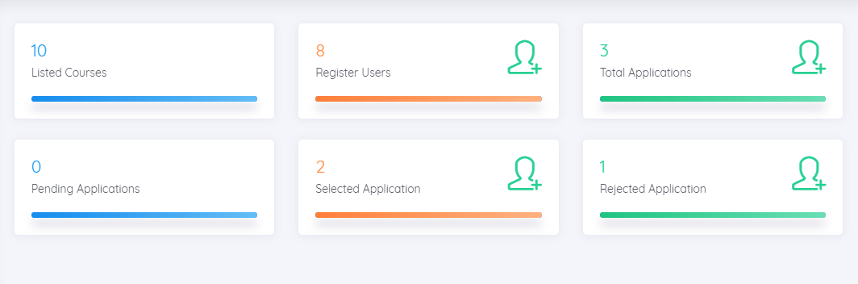

SYSTEM TESTING

System testing is the stage of implementation, which is aimed at ensuring that the system works accurately and efficiently before live operation commences. Testing is the process of executing the program with the intent of finding errors and missing operations and also a complete verification to determine whether the objectives are met and the user requirements are satisfied. The ultimate aim is quality assurance.

Tests are carried out and the results are compared with the expected document. In the case of erroneous results, debugging is done. Using detailed testing strategies a test plan is carried out on each module. The various tests performed in “Network Backup System” are unit testing, integration testing and user acceptance testing.

Unit Testing

The software units in a system are modules and routines that are assembled and integrated to perform a specific function. Unit testing focuses first on modules, independently of one another, to locate errors. This enables, to detect errors in coding and logic that are contained within each module. This testing includes entering data and ascertaining if the value matches to the type and size supported by java. The various controls are tested to ensure that each performs its action as required.

Integration Testing

Data can be lost across any interface, one module can have an adverse effect on another, sub functions when combined, may not produce the desired major functions. Integration testing is a systematic testing to discover errors associated within the interface. The objective is to take unit tested modules and build a program structure. All the modules are combined and tested as a whole. Here the Server module and Client module options are integrated and tested. This testing provides the assurance that the application is well integrated functional unit with smooth transition of data.

User Acceptance Testing

User acceptance of a system is the key factor for the success of any system. The system under consideration is tested for user acceptance by constantly keeping in touch with the system users at time of developing and making changes whenever required.

DESIGN AND IMPLEMENTATION CONSTRAINTS

Some of the design and implementation constraints identified are listed below:

- Student is not allowed to register with same email and contact number (Unique email and contact number will be registered).

- Student not has any rights to edit any data in the admission form after submission.

- Once admission application selected user can upload their docs once..

- This system is not support distributed database Facility.

- System is limited to HTTP/HTTPS Protocols.

Implementation is the stage in the project where the theoretical design is turned into a working system and is giving confidence on the new system for the users that it will work efficiently and effectively. It involves careful planning, investigation of the current system and its constraints on implementation, design of methods to achieve the change over, an evaluation of change over methods. Apart from planning major task of preparing the implementation are education and training of users. The implementation process begins with preparing a plan for the implementation of the system. According to this plan, the activities are to be carried out, discussions made regarding the equipment and resources and the additional equipment has to be acquired to implement the new system. In network backup system no additional resources are needed.

Implementation is the final and the most important phase. The most critical stage in achieving a successful new system is giving the users confidence that the new system will work and be effective. The system can be implemented only after thorough testing is done and if it is found to be working according to the specification. This method also offers the greatest security since the old system can take over if the errors are found or inability to handle certain type of transactions while using the new system.

User Training

After the system is implemented successfully, training of the user is one of the most important subtasks of the developer. For this purpose user manuals are prepared and handled over to the user to operate the developed system. Thus the users are trained to operate the developed system. Both the hardware and software securities are made to run the developed systems successfully in future. In order to put new application system into use, the following activities were taken care of:

- Preparation of user and system documentation

- Conducting user training with demo and hands on

- Test run for some period to ensure smooth switching over the system

The users are trained to use the newly developed functions. User manuals describing the procedures for using the functions listed on menu are circulated to all the users. It is confirmed that the system is implemented up to users need and expectations.

Security and Maintenance

Maintenance involves the software industry captive, typing up system resources .It means restoring something to its original condition. Maintenance follows conversion to the extend that changes are necessary to maintain satisfactory operations relative to changes in the user’s environment. Maintenance often includes minor enhancements or corrections to problems that surface in the system’s operation. Maintenance is also done based on fixing the problems reported, changing the interface with other software or hardware enhancing the software.

Any system developed should be secured and protected against possible hazards. Security measures are provided to prevent unauthorized access of the database at various levels. An uninterrupted power supply should be so that the power failure or voltage fluctuations will not erase the data in the files.

Password protection and simple procedures to prevent the unauthorized access are provided to the users .The system allows the user to enter the system only through proper user name and password

SUPPLEMENTARY REQUIREMENTS

Reduce the Cost of Admission Process: The main aim of the System is to reduce the cost needed for Admission Process, so it automatically reduces the manual power needed to perform the entire task and improve the quality of the work.

Increase the Quality of the Process: The System facilitates the work of the universities and the same time it must reduce the work load of the organization with expected quality. Quality in the sense, the system try to avoid the mistakes that are usually happen during the Admission Process because names of the students sometimes missed in the selected list and call letters for the students also not send properly to the qualified students. Make the Interface Simple as Possible.

Reduced Time: To perform any task time is one of the important factors to consider. If the system not utilize properly time, than the entire aim of system is fails and the sys tem is fails to reach its goal. So time take to process all these activities should be less but the output should be effective.

OTHER NONFUNCTIONAL REQUIREMENTS

Performance Requirements

Some Performance requirements identified is listed below:

- The database shall be able to accommodate a minimum of 10,000 records of

students.

- The software shall support use of multiple users at a time.

- There are no other specific performance requirements that will affect development.

Security Requirements

Some of the factors that are identified to protect the software from accidental or malicious access, use, modification, destruction, or disclosure are described below. Specific requirements in this area could include the need to:

- Utilize certain cryptographic techniques

- Keep specific log or history data sets

- Assign certain functions to different modules

- Restrict communications between some areas of the program

- Check data integrity for critical variables

- Later version of the software will incorporate encryption techniques in the user/license authentication process

Portability Requirements

Some of the attributes of software that relate to the ease of porting the software to other host machines and/or operating systems. This may include:

Java is used to develop the product. So it is easiest to port the software in any environment.

Maintainability

The user will be able to reset all options and all stored user variables to default settings .

Reliability

Some of the attributes identified for the reliability is listed below:

All data storage for user variables will be committed to the database at the time of entry.

Data corruption is prevented by applying the possible backup procedures and techniques.

Usability requirements

Some of the usability requirements identified for this system are listed below:

- A logical interface is essential to an easy to use system, speeding up common tasks.

- Error prevention is integral to the system and is provided in a number of formats from sanity checks to limiting free-text input.

CONCLUSION

In this way we are going to develop college admission system, which is helpful for Reduction in manual work so less manpower required. Students’ records can be accessed within few seconds, Clarity in account section. Our system primarily focuses on building an efficient and user friendly communication system for the educational institutions.

REFERENCE

  - PHP.net.

  - Sitepoint.

  - W3School.

  - Google web search

  - Wikipedia

